**CP Club 365Days Challenge**

**Programming language – C++**

**Problem Statement**

[https://practice.geeksforgeeks.org/problems/non-repeating-character-1587115620/1?page=1&difficulty[]=0&category[]=Strings&sortBy=submissions](https://practice.geeksforgeeks.org/problems/non-repeating-character-1587115620/1?page=1&difficulty%5b%5d=0&category%5b%5d=Strings&sortBy=submissions)

**Your Code**:

// 0x59Day of 0x365Days challenge

// VEDANT BHARAD

// 15-12-2022

//{ Driver Code Starts

#include <bits/stdc++.h>

using namespace std;

// } Driver Code Ends

class Solution

{

    public:

    //Function to find the first non-repeating character in a string.

    char nonrepeatingCharacter(string S)

    {

        for(int loop=0; loop<S.length(); loop++)

        {

            string temp(1, S[loop]);

            size_t firstIndex = S.find(temp);

            size_t secondIndex=0;

            secondIndex= S.find(temp, firstIndex+1);

            if(secondIndex>S.length())

            {

                return S[loop];

            }

        }

        return '$';

    }

};

//{ Driver Code Starts.

int main() {

    int T;

    cin >> T;

    while(T--)

    {

        string S;

        cin >> S;

        Solution obj;

        char ans = obj.nonrepeatingCharacter(S);

        if(ans != '$')

        {

            cout << ans;

        }

        else cout << "-1";

            cout << endl;

    }

    return 0;

}

// } Driver Code Ends

**Output (Screen Shot)**:

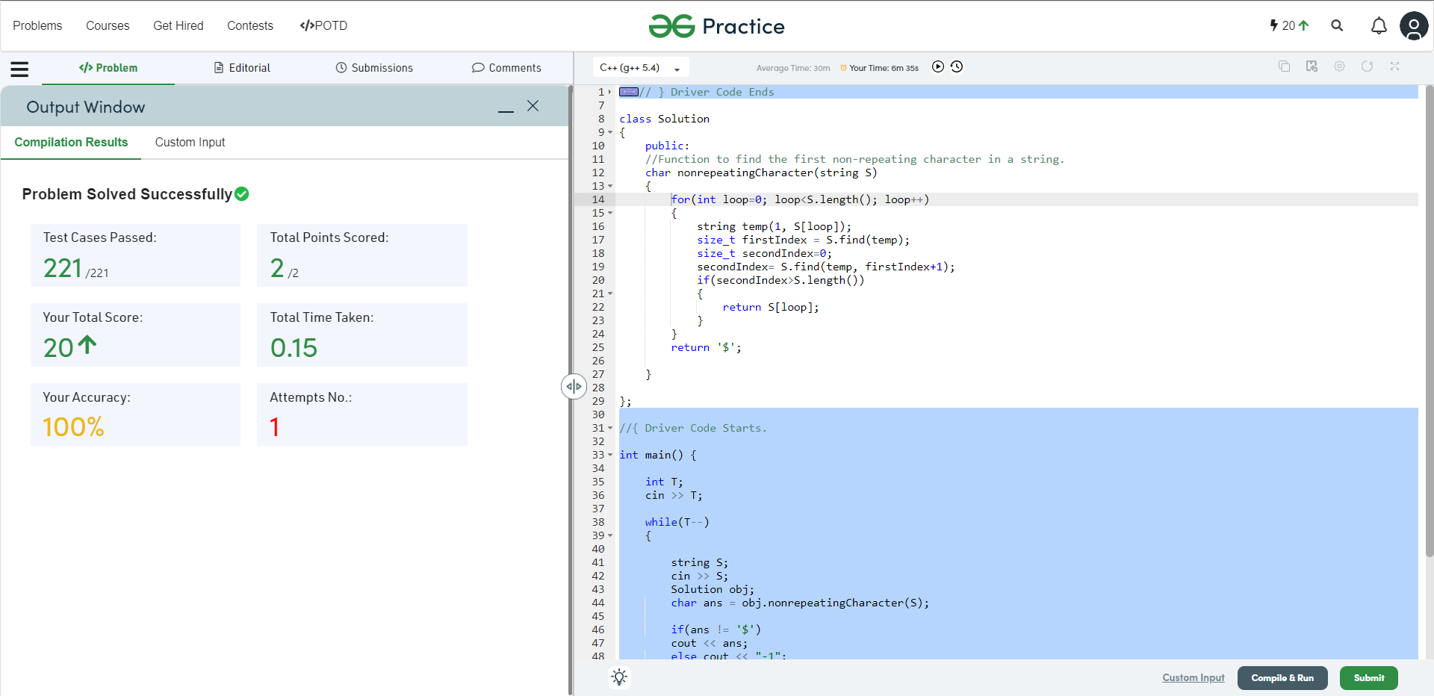

**Understanding about problem:**

1. In this task there will be one string as a input of our function.
2. In this task I need to find and return first character which is non-repeating character if all character are repeating then return ‘$’.

Note: If you can't understand the problem, feel free to contact us and we'll help you. Please don't copy and paste from anywhere.

ALL THE BEST

Team CP Club